**Task 1: Student and Course Enrollment System**

Tables: **Student**(sid, sname, ccode, dob, address),**Course**(ccode, cname, fees)

Problem Statements:

Q1) Write a query to add 5 students records into the Student table, including their student ID, name, course code, date of birth, and address.

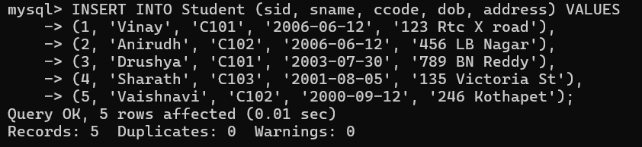

Q2) Write a query to add 3 courses into the Course table, with course code, name, and fees.

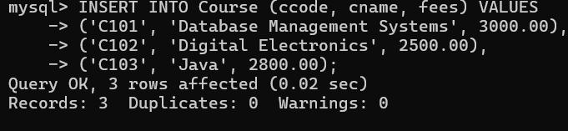

Q3) Write a query to modify the address of a student identified by his sid is 2.

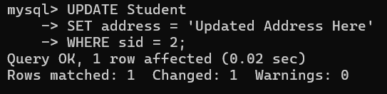

Q4) Write a query to modify the course fees for the course with ccode = 'C101' by increasing it by 4%.

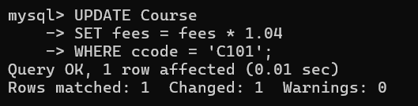

Q5) Write a query to remove the record of a student whose sid belongs to 5.

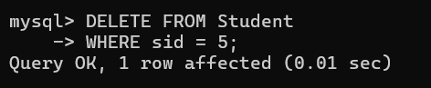

Q6) Write a query to display all the students enrolled in the course ccode belongs 'C102'.

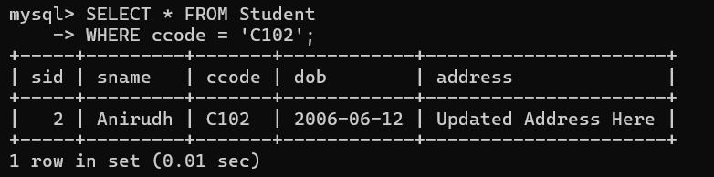

Q7) Write a query to display the names and fees of all courses where the fees are greater than 2000.

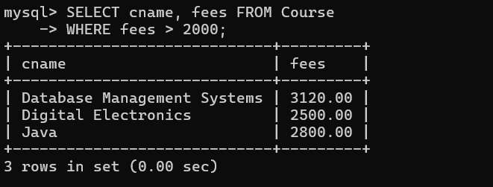

**Task 2: University System with Departments**

**Tables:**

**Student**(sid, sname, ccode, dob, address)**,**

**Course**(ccode, cname, fees, did)**,**

**Department**(did, dname, location)

Problem Statements:

Q8) Write a query to add 3 departments into the Department table with department ID, name, and location.

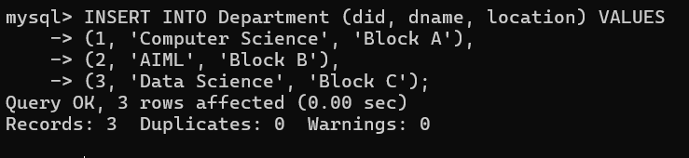

Q9) Write a query to change the location of the department number 1 to 'New York'.

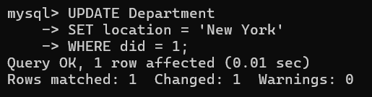

Q10) Write a query to remove the department record whose did belong to 3.

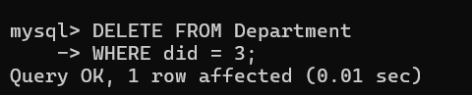

Q11) Write a query to find all students and display their names along with the dob who born between January and March

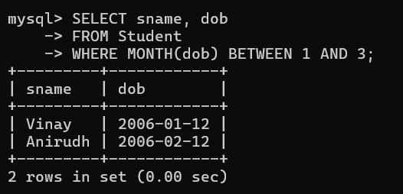

Q12) Write a query to display the details of courses taught by departments located in 'California'.

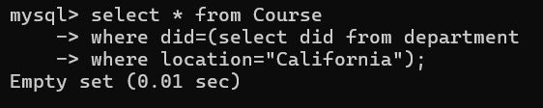

**Task 3: University System with Faculty**

**Tables:**

**Student**(sid, sname, ccode, dob, address)

**Course**(ccode, cname,did, fees)

**Departmen**t(did, dname, location)

**Faculty**(fid, fname, sal, designation, doj, did)

Problem Statements:

Q13) Write a query to add 4 faculty members into the Faculty table with their ID, name, salary, designation, date of joining, and department ID.

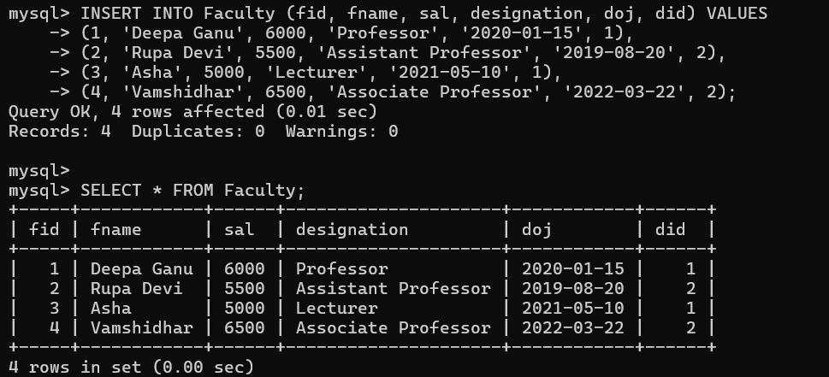

Q14) Write a query to remove the faculty member who joined recently. 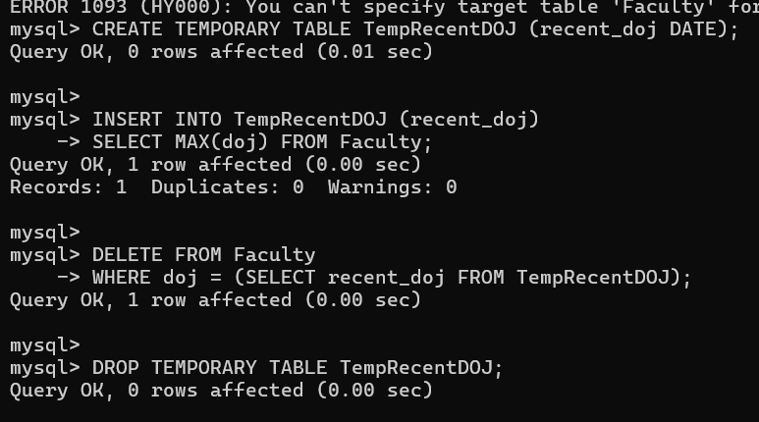

Q15) Write a query to display all faculty members who have joined before 2022.

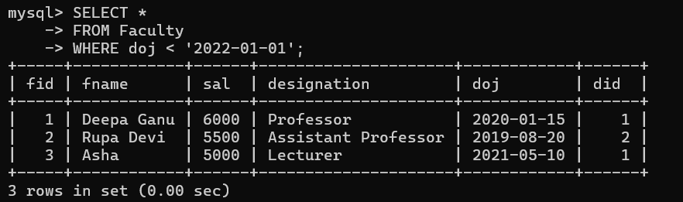

Q16) Write a query to display the department  wise monthly expenditure on salaries of faculty members

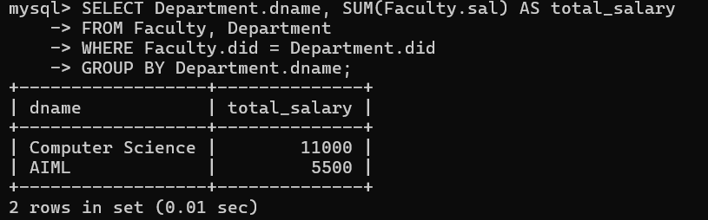

Q17) Write a query to display the faculty member(s) with the highest salary in each department.

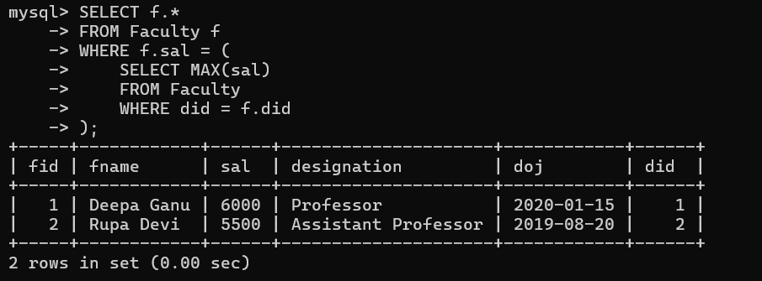

Q18) Write a query to increment the salary by 12 % of their salary who teaches DBMS.

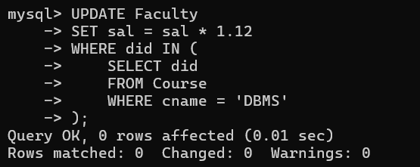

**Task 4: Employee and Department System**

**Tables:**

**Employee**(eid, ename, salary, doj, comm,did)

**Department**(did, dname, location)

Problem Statements:

Q19) Write a query to add 5 employees into the Employee table with their employee ID, name, salary, date of joining,did and commission at a time.

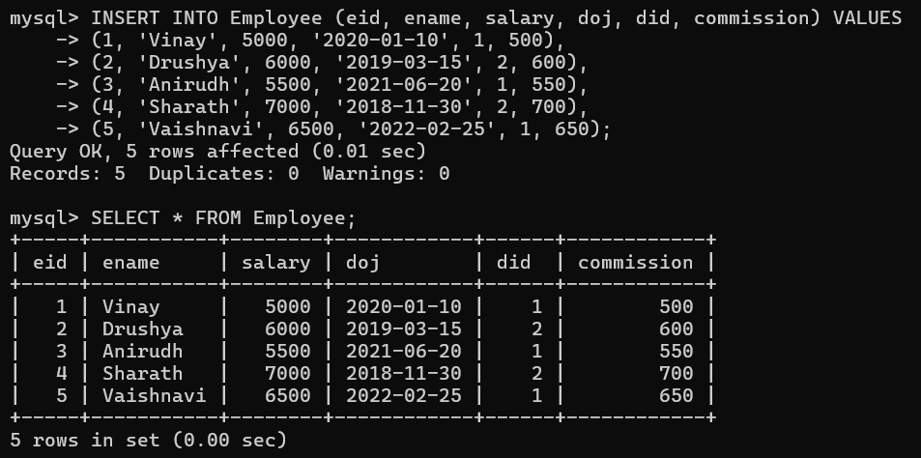

Q20) Write a query to give extra 5% commission for the employees whose experience is more than 5 years.

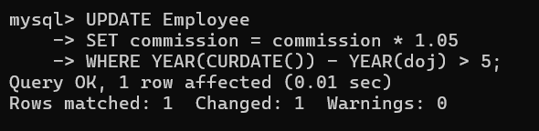

Q21) Write a query to remove the record of the employee who has been with the company for the longest time (use a subquery to identify the employee with the earliest date of joining).

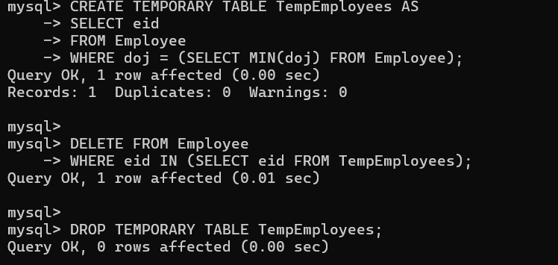

Q22) Write a query to display the name and salary of employees who have a salary greater than 5000.

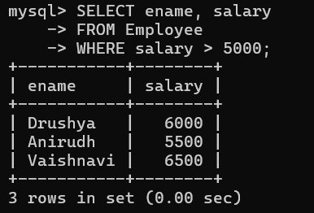

Q23) Write a query to display the details of employees who work in departments located in 'San Francisco'.

